**NAAN MUDHAVALVAN- SALESFORCE REPORT**

**A CRM Application To Manage The Mall**

**PROJECT CREATED BY**

**BE –V SEMESTER**

**SANJAY. R 422422104049**

**GUNA. P 422422104050**

**MABEL FLORENCE. R 422422104052**

**BALA KRISHNAN. S 422422104054**

**DEPARTMENT OF COMPUTER SCIENCE AND ENGINEERING UNIVERSITY COLLEGE OF ENGINEERING TINDIVANAM**



ANNA UNIVERSITY ,CHENNAI -60025

Table of Contents

**1.Project Overview**3

**2.Objectives** 3

Busines Goals3

Specific Outcomes4

# 3. Salesforce Key Features and Concepts Utilized4

Creating Custom Objects4

Automation4

Reports and Dashboards…………………………………………………………………………………........4

Asynchronous Apex………………………………………………………………………..............................4

Custom Validation Rules……………………………………………………………………………………..4

# 4.Detailed Steps to Solution Design………………………………………………..5

# Why Are We Using Salesforce Platform for This Project? ………………………………………..5

# Creating developer account………………………………………………………………………...5

# Creating cutom objects……………………………………………………………………………..6

Create the Lightning App………………………………………………………………………......9

Steps to Create Custom App in Salesforce…………………………………………………………9

Record Insertion …………………………………………………………………………………..10

Create flows……………………………………………………………………………………….12

Apex Triggers……………………………………………………………………………………..15

Asynchronous Apex…………………………………………………………………………….....19

Create Reports and Dashboards …………………………………………………………………..21

# 5. Testing and Validation………………………………………………………… 25

# 6. Key Scenarios Addressed by Salesforce in the Implementation Project

# 7.Conclusion……………………………………………………………………….26

# Project Overview

# The Management App is a dynamic and scalable CRM system designed specifically for managing commercial malls. Built on the Salesforce platform, the application offers solutions to the challenges faced by mall administrators, including managing tenant information, tracking leases, and resolving tenant issues efficiently.

# Additional Features of the Management App

# Scalable Architecture: The app can be expanded to handle multiple malls and thousands of tenant records without performance degradation.

# Mobile Access: Fully accessible via Salesforce mobile apps, ensuring on-the-go usability for mall administrators and staff.

# Customizable Analytics: Personalized dashboards and reports can be tailored to specific management needs.

# The app addresses both day-to-day operations and long-term planning requirements, making it a comprehensive tool for mall administrators.

# Objectives

The objectives of the Management App are both business-oriented and functionality-driven:

* **Business Goals**:
  + **Enhanced Operational Efficiency**: Automate and streamline lease tracking, tenant communication, and data management processes.
  + **Improved Tenant Relationship Management**: Foster a more proactive, organized approach to handling tenant concerns, lease inquiries, and contract management.
  + **Strategic Planning and Insights**: Utilize Salesforce analytics to gain insights into occupancy trends, tenant performance, and potential growth opportunities within the mall
* **Specific Outcomes**:
  + **Accurate Lease Tracking**: Automate reminders for lease renewals and terminations, reducing the risk of lost revenue or lease lapses.
  + **Enhanced Communication**: Centralize communication with tenants to address inquiries and resolve issues quickly.
  + **Informed Decision Making**: Implement real-time dashboards for metrics like occupancy rates, revenue projections, and tenant feedback.

# Salesforce Key Features and Concepts Utilized

* **Custom Objects**: Lease, Tenant, and Tenant Issues for data management.
* **Automations**: Workflows, Apex triggers, and flows to streamline repetitive tasks.
* **Reports and Dashboards**: Insights on lease statuses, tenant issues, and financial summaries.
* **Asynchronous Apex**: For scheduled tasks such as periodic updates and batch processing.
* **Email Templates**: Configured pre-defined templates for automated tenant communications, such as reminders for overdue rent or service updates.
* **Chatter Integration**: Enabled internal collaboration by integrating Salesforce Chatter for real-time updates and discussions on tenant-related issues.
* **Audit Trails**: Leveraged Salesforce’s tracking mechanisms to monitor changes to key records, enhancing accountability.
* **Custom Validation Rules**: Implemented rules to ensure data integrity, such as validating tenant PAN numbers or mandatory fields during lease creation.

The Salesforce ecosystem provides the flexibility to adapt to the mall’s specific operational needs while ensuring a user-friendly interface for all stakeholders.

# Detailed Steps to Solution Design

**CRM Application to Manage the Mall**

This section outlines the structured approach to building the CRM application step-by-step.

1. **Why Are We Using Salesforce Platform for This Project?**  
   Salesforce offers a robust, secure, and scalable platform for developing CRM applications with minimal code and extensive customization options. Features like Lightning UI, workflows, automation tools, and advanced reporting make Salesforce ideal for managing a mall’s operations.
2. **Creating Developer Account**
   * A Salesforce developer account is created to provide access to the Salesforce Lightning platform and tools needed for custom app development.

**Figure:1**

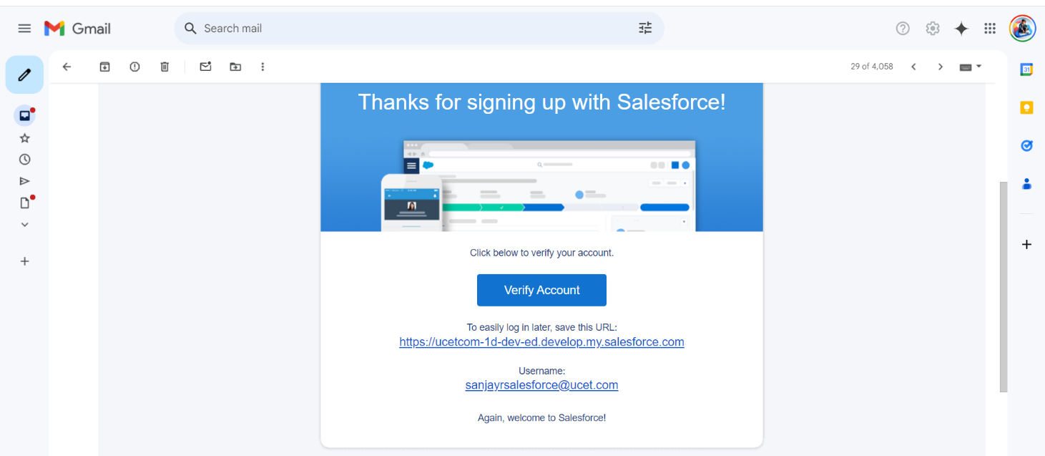

1. **Create Custom Objects**  
   Custom objects are created to manage mall-specific data:
   * **Tenant Object**: For storing tenant details like contact info, lease dates, and PAN card details

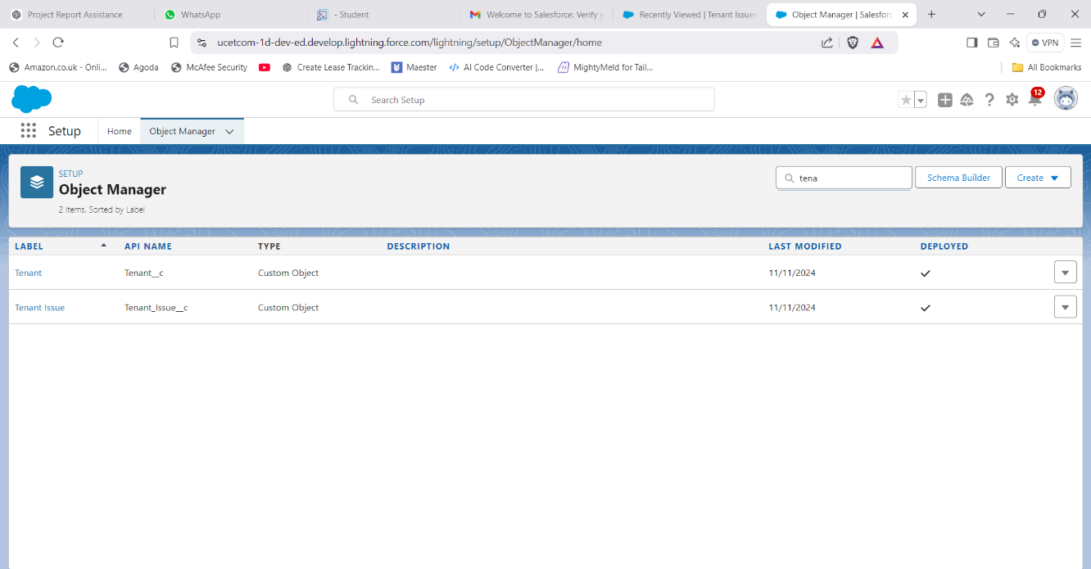**Figure**:2

* + **Lease Tracking Object**: For tracking lease agreements, including payment statuses.

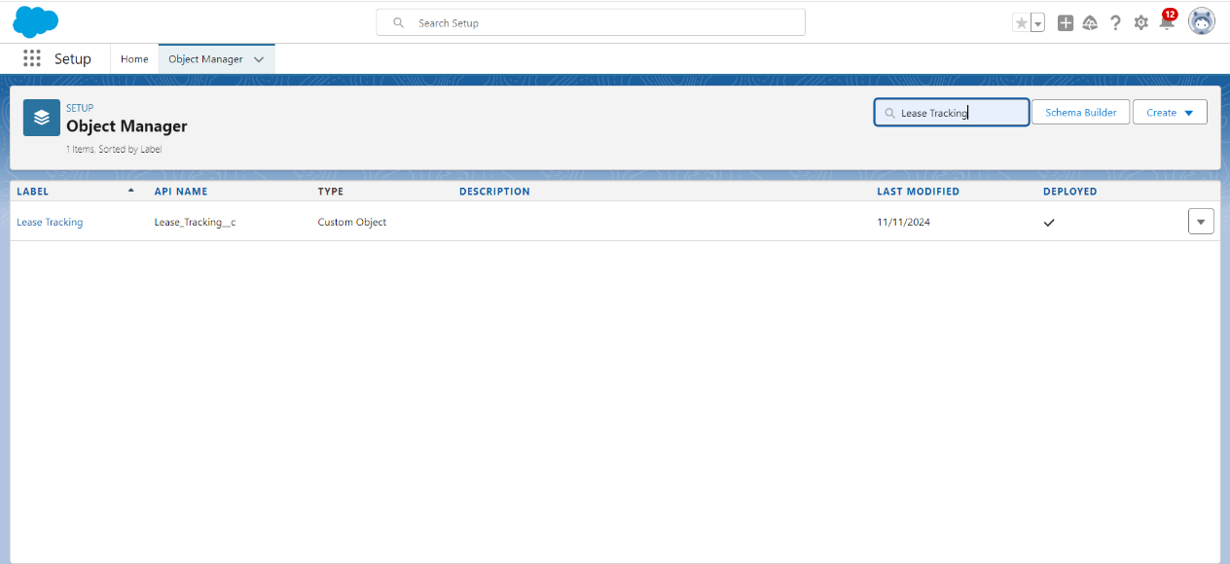**Figure**:3

* + **Tenant Issues Object**: For logging tenant complaints, service requests, and maintenance records.

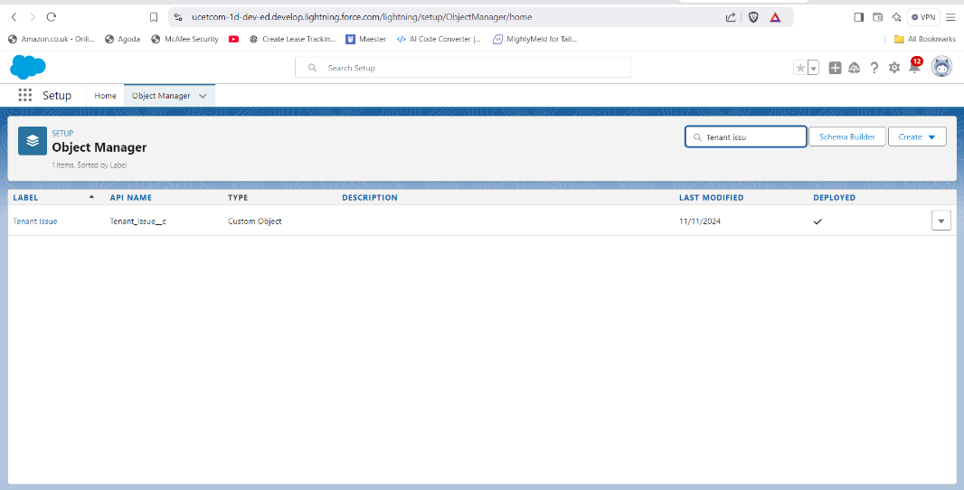 **Figure**:4

1. **Create Custom Tabs for Tenant Object**

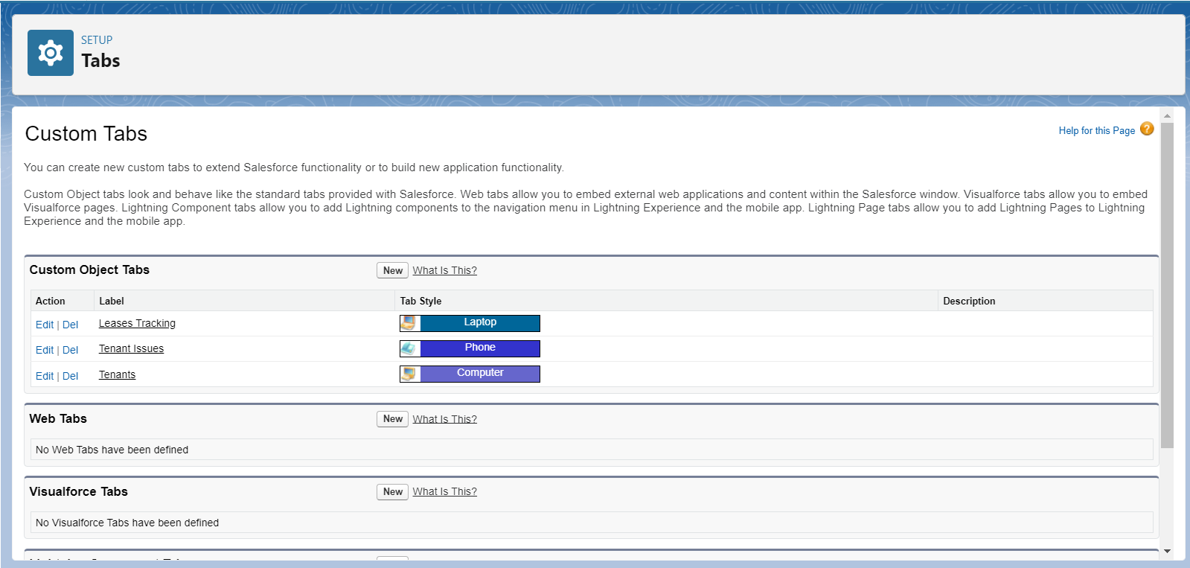**Figure**:5

* + Custom tabs are designed to allow easy access to the Tenant object through the Salesforce UI.

1. **Create Fields and Relationships**  
   Fields are created to capture necessary data and relationships are established between objects to ensure seamless data interaction:
   * **Tenant Object Fields**: Tenant Name, Contact Details, PAN Number, Lease ID (lookup).

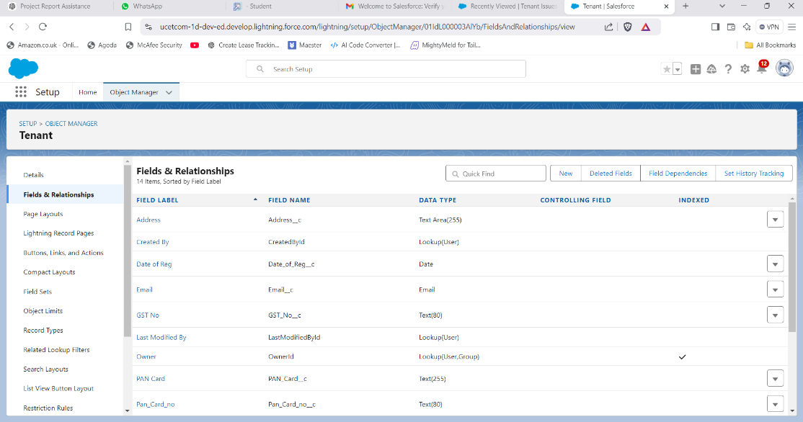**Figure**:6

* + **Lease Tracking Fields**: Lease Start Date, End Date, Total Rent, Payment Status.

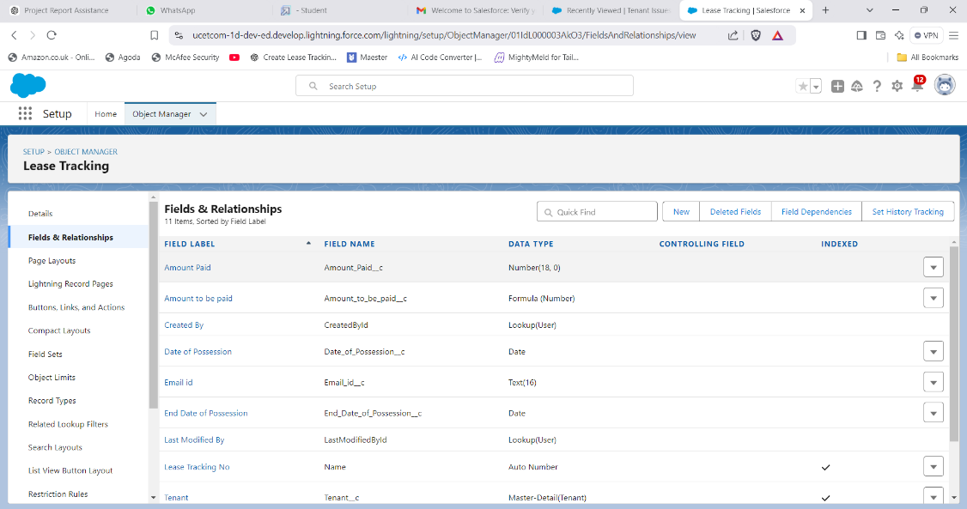**Figure**:7

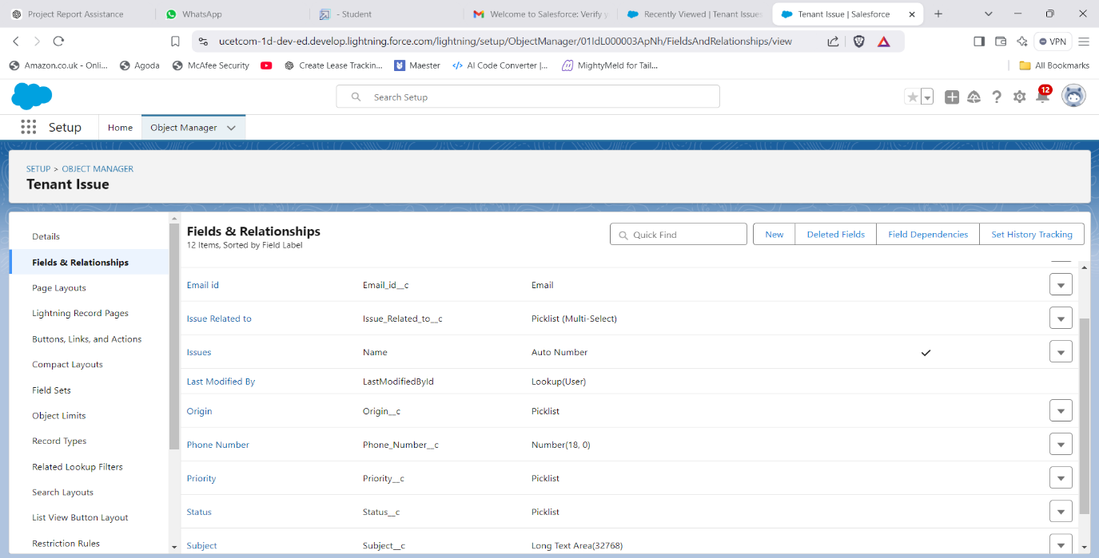

* + **Tenant Issues Fields**: Issue ID, Description, Status, Assigned To,

1. **Create the Lightning App**
   * The Lightning app is designed to offer an intuitive interface with easy navigation between Tenant, Lease Tracking, and Tenant Issues data.
2. **Steps to Create Custom App in Salesforce**
   * Navigate to the App Builder and create a custom app with navigation items for custom objects, dashboards, and reports. Additionally, I inserted a logo for smart mall app.

**Figure**:8

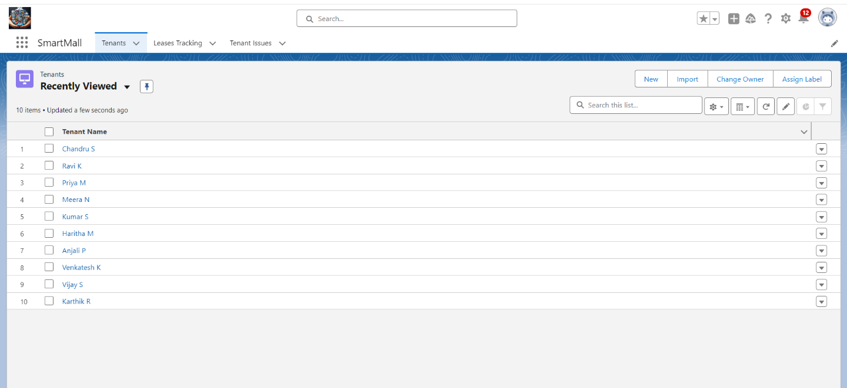**Figure**:9

1. **Record Insertion**  
   Records are inserted for testing and demonstration purposes:
   * **Tenant Object**: Add tenant details manually or through data import tools.

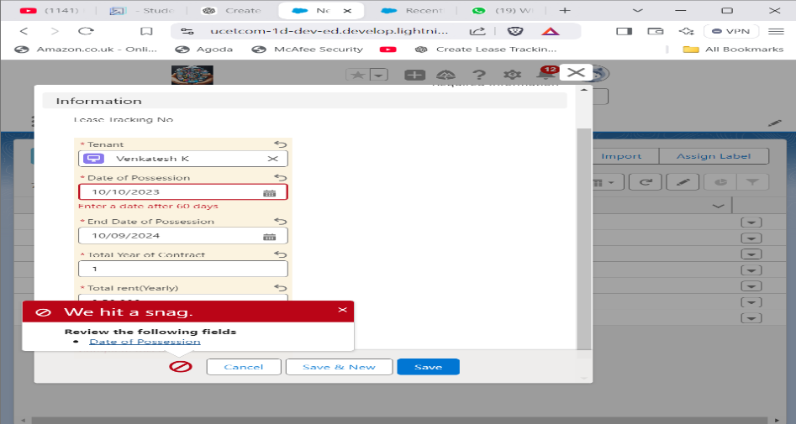**Figure:10**

**Figure**:11

* + 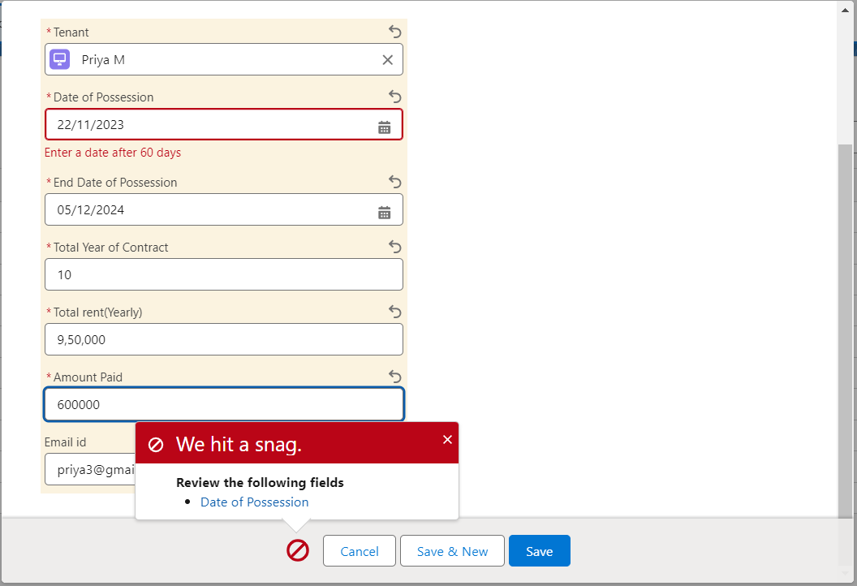**Lease Tracking Object**: Add lease agreement details linked to tenants.

**Figure:12**

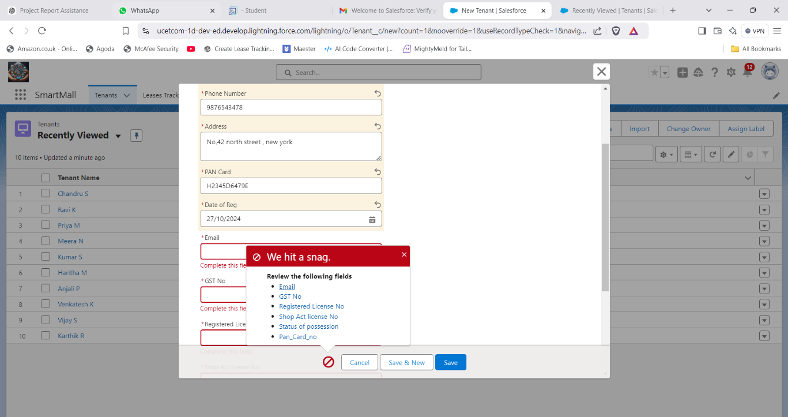

* + **Tenant Issues Object**: Log service requests or complaints raised by tenants.

**Figure**:13 **Figure**:14

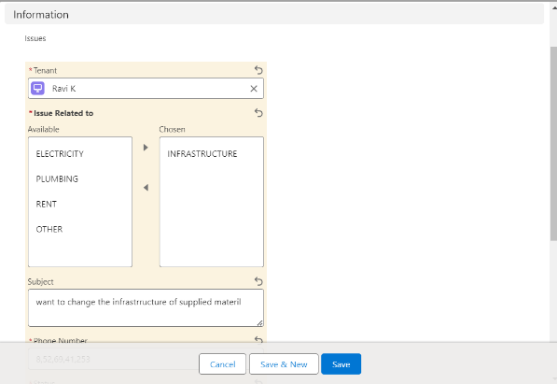 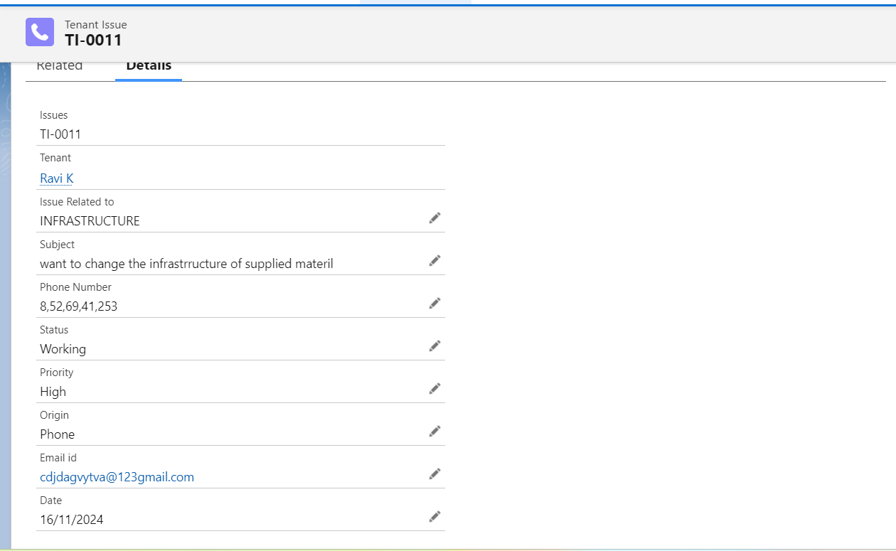

1. **Create Flows**

1) To create a flow click on setup==> Flow ==> Click on New Flow==> Select Record Triggered Flow   
2) In Trigger the flow when Select A record is created

3) Select Condition required All Conditions are met (AND)

4) Select Field - GST_No__c , Operator - Is Null , Value - True.

5)Optimize the Flow for:  Actions and Related Records

6)Add Element and choose ACTION  in the search bar Search Send Email.

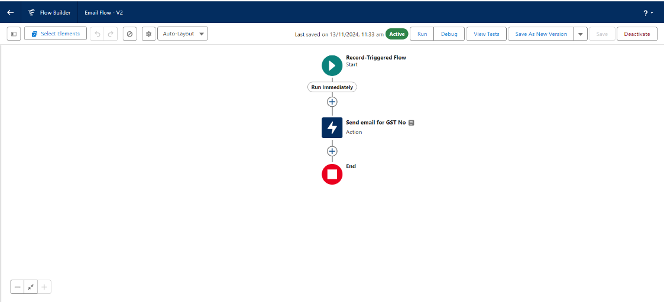**Figure:15**

7) Label Name - Send email for Gst no,  Description -  This email is to alert the tenant that he or she has not submitted the GST NO yet.

8)  Include Body And Create a Resource - Text Template As below-

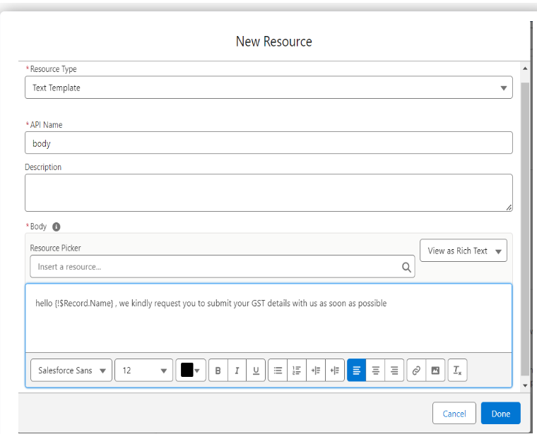**Figure**:16

* + **Record-Triggered Flow on Tenant Object**:

Automatically update the tenant’s status based on certain conditions, such as lease renewal or overdue payments.

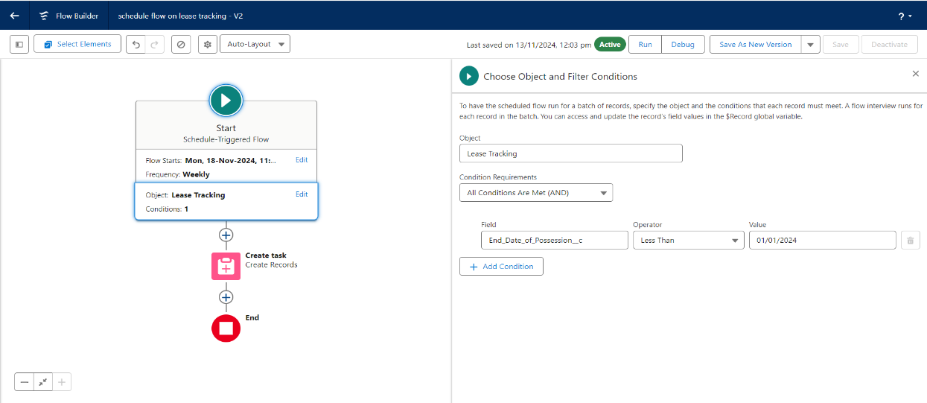**Figure**:17

* + 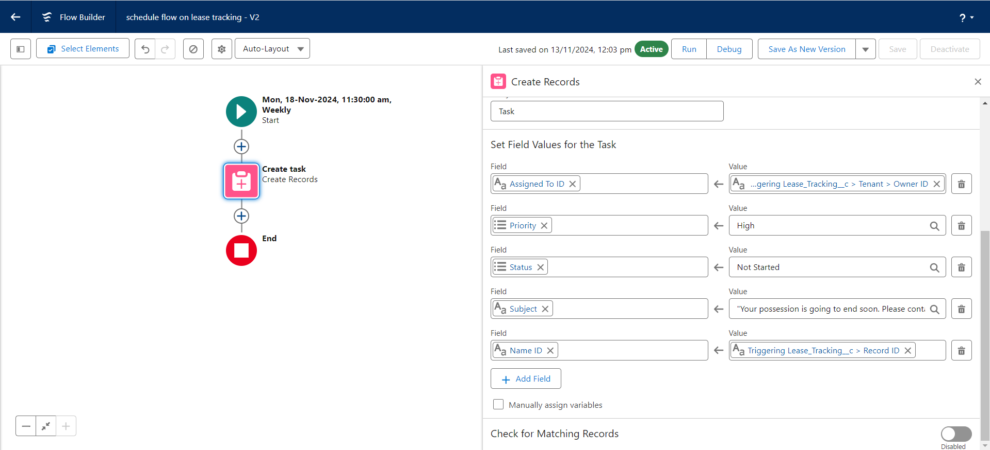**Scheduled Flow on Lease Management Object**: Sends reminders for upcoming lease expirations to tenants and administrators.

**Figure**:18

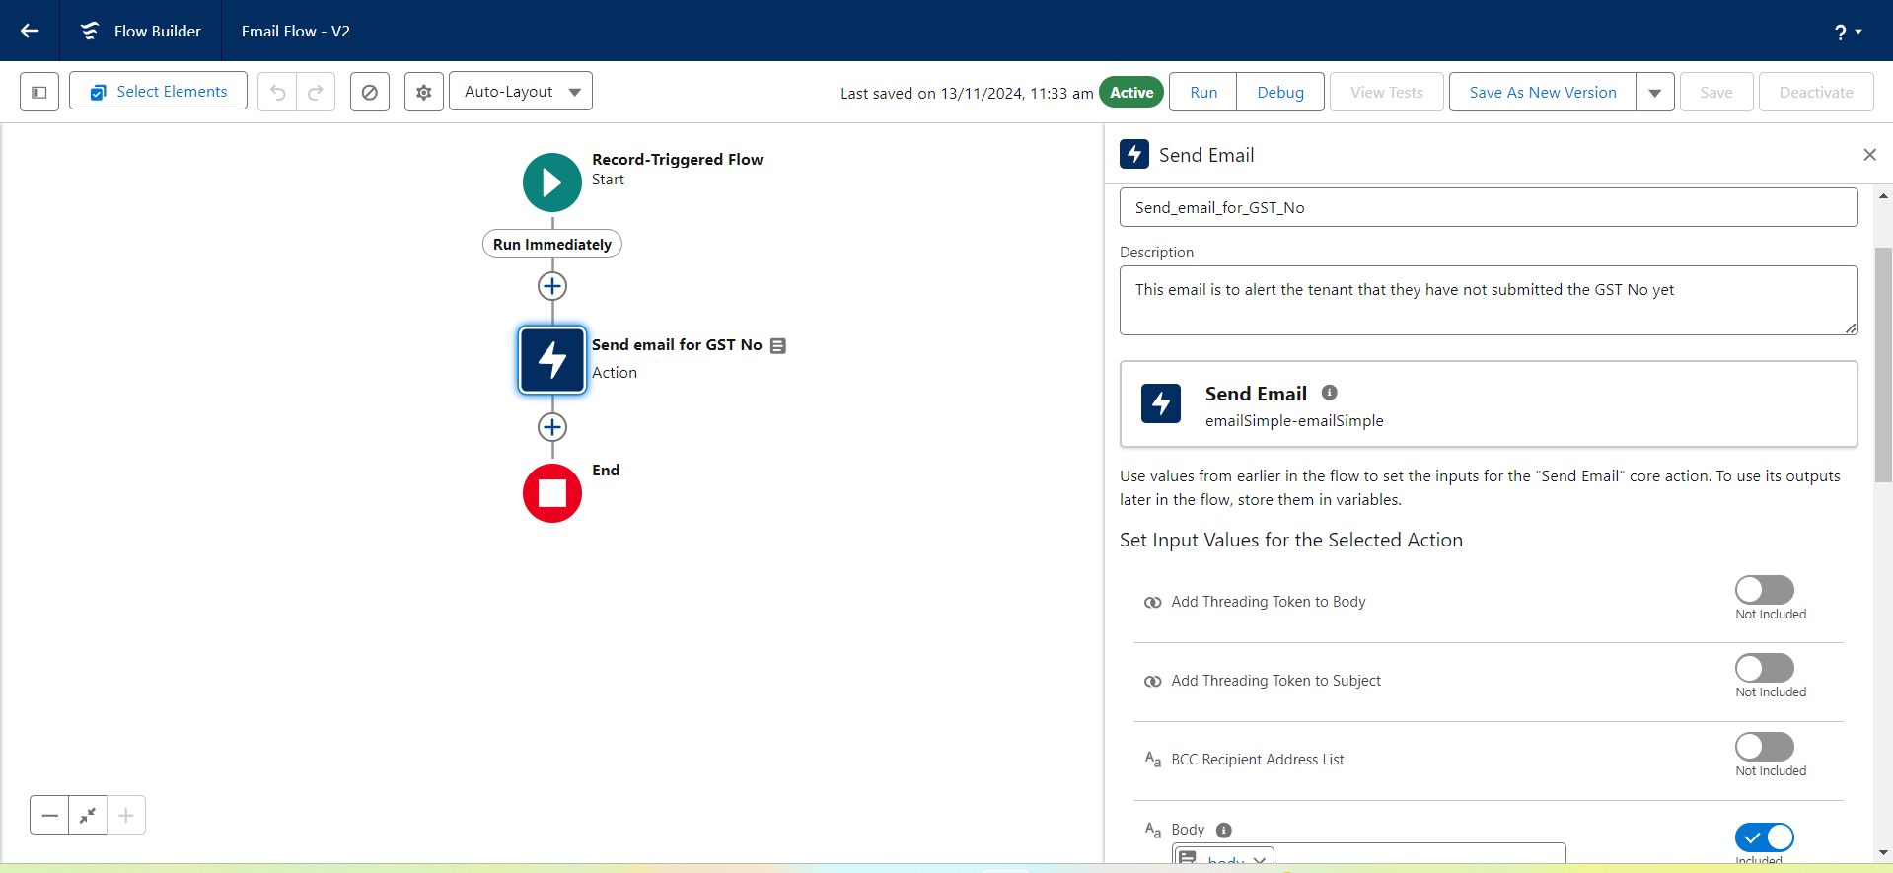**Figure:19**

1. **Apex Triggers**

* **Trigger to Send Email for Unpaid Rent**: Automatically notify tenants if 50% of the rent remains unpaid after a specific period.

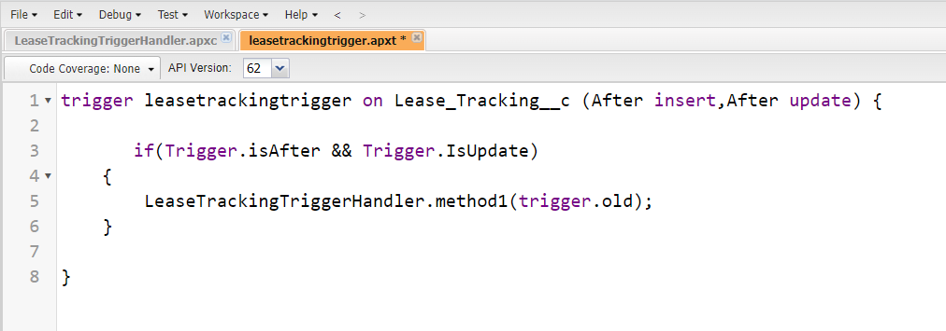**Figure** :**20**

1. Click on the gear icon and click on the developer console.

2)  Click on file select New Apex Trigger

3) Name- leasetrackingtrigger, Object —> Lease_Tracking__c

4) Use Event - After insert and After Update and Use Trigger Context Variables as IsAfter and IsUpdate.

Trigger : -

CODE SNIPPET :

trigger leasetrackingtrigger on Lease_Tracking__c (After insert,After update) {

       if(Trigger.isAfter && Trigger.IsUpdate)

    {

        LeaseTrackingTriggerHandler.method1(trigger.old);

    }

}

**Trigger Handler: -**

1) Create an apex class and Name it LeaseTrackingTriggerHandler

CODE SNIPPET : -

public class LeaseTrackingTriggerHandler {

     public static void method1(List<Lease_Tracking__c> lt1)

   {

       for(Lease_Tracking__c lt2: lt1 )

       {

           if(lt2.Amount_to_be_paid__c > (lt2.Total_rent_Yearly__c)/2)

           {

               Messaging.SingleEmailMessage M = New Messaging.SingleEmailMessage();

                List<String> ToADD = New List<String>{lt2.Email_id__c};

                      M.setToAddresses(ToADD);

                      M.setSubject('Regarding the Pending Rent');

                      M.setPlainTextBody('Hello, This is an Reminder for you to complete your due rent by the end this month, your due rent thatneeds to be paid is' +lt2.Amount_to_be_paid__c);

                    List<Messaging.Email> AB = New List<Messaging.Email>{};

                    AB.add(M);

                    Messaging.sendEmail(AB);

           }

       }

   }

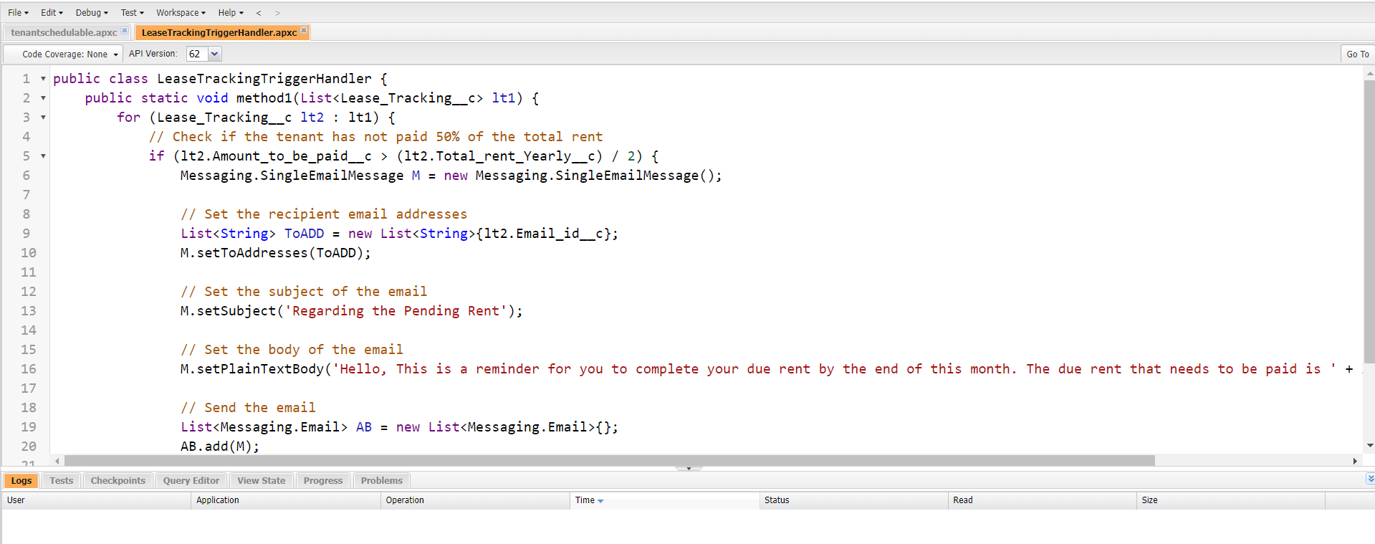**Figure** :**21**

* **Trigger to Validate PAN Card**: Ensures the PAN number entered is valid, throwing an error otherwise.
  1. Click on the gear icon and click on the developer console.

2)  Click on file select New Apex Trigger

3) Name- TenantTrigger, Object -  Tenant

4) Use Events - Before insert and Trigger context Variable – IsBefore

**Figure:22**

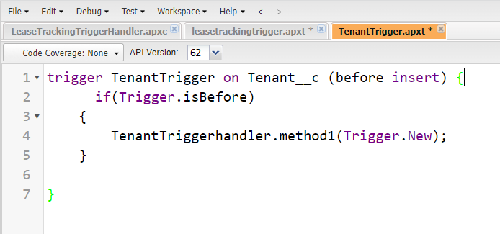

### 

### **Trigger : -**

#### CODE SNIPPET :

trigger TenantTrigger on Tenant__c (before insert) {

      if(Trigger.isBefore)

    {

        TenantTriggerhandler.method1(Trigger.New);

    }

}

**Trigger Handler : -**

1) Create an apex class and Name it TenantTriggerhandler

CODE SNIPPET: -

public class TenantTriggerhandler {

       public static void method1(List<Tenant__c> te)

    {

        for(Tenant__c tenant : te)

        {

            if(tenant.Pan_Card_no__c.length() > 10)

            {

               tenant.addError('This Pan Card number is invalid, Please Enter Valid Pan Card number');

            }

        }

    }

}

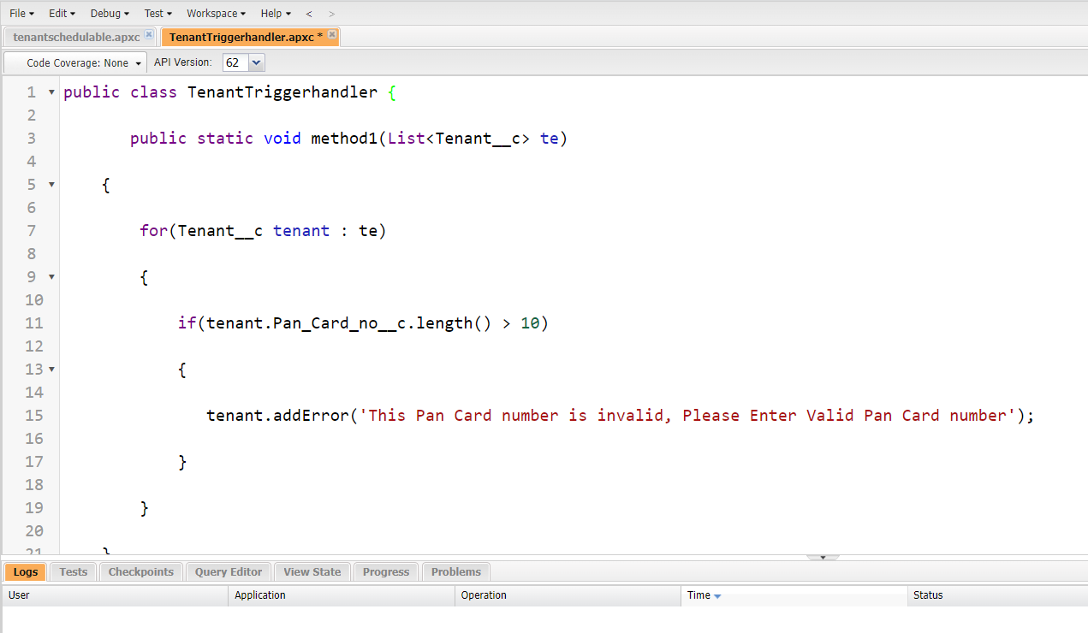**Figure** **:23**

1. **Asynchronous Apex**

**Schedule Apex**: Batch process tenant payment data to generate a daily summary for the management team.

**Delete the Tenant Records Monthly whose Status Of Possession is closed.**

1)  Create a class with name tenantschedulable

2) Give extension Schedulable to the class.

3) Open the Anonymous Window.

4)   Schedule the class-

tenantschedulable a = new tenantschedulable();

string cron =  '0 0 0 1 * ? * ';

system.schedule('Delete the records monthly', cron, a);

### **CODE SNIPPET : -**

public class tenantschedulable implements Schedulable

{

public void execute(Schedulablecontext sc)

    {

       list<Tenant__c>  ten = [SELECT Id, Status_of_Possession__c FROM Tenant__c ];

 list<Tenant__c> tenantstodelete = New List<Tenant__c>();

        for(Tenant__c te: ten)

        {

            if(te.Status_of_Possession__c == 'Closed')

            {

                tenantstodelete.add(te);

            }

        }

        Delete tenantstodelete;

    }

}

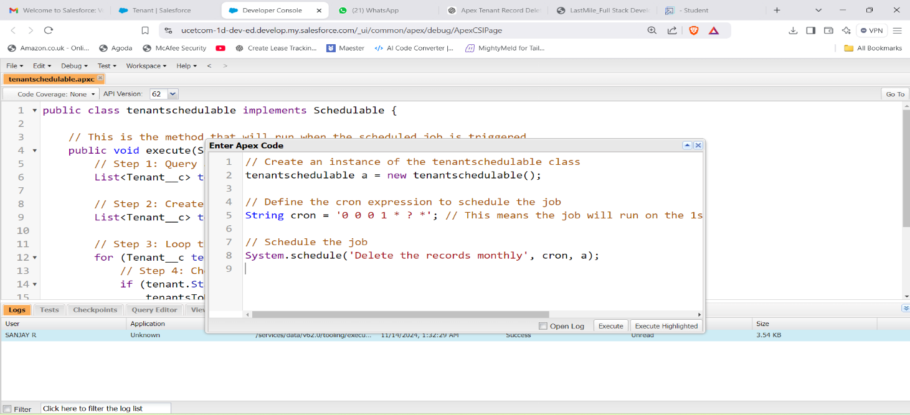**Figure :24**

All Jobs are scheduled at correctly at 12:00 AM

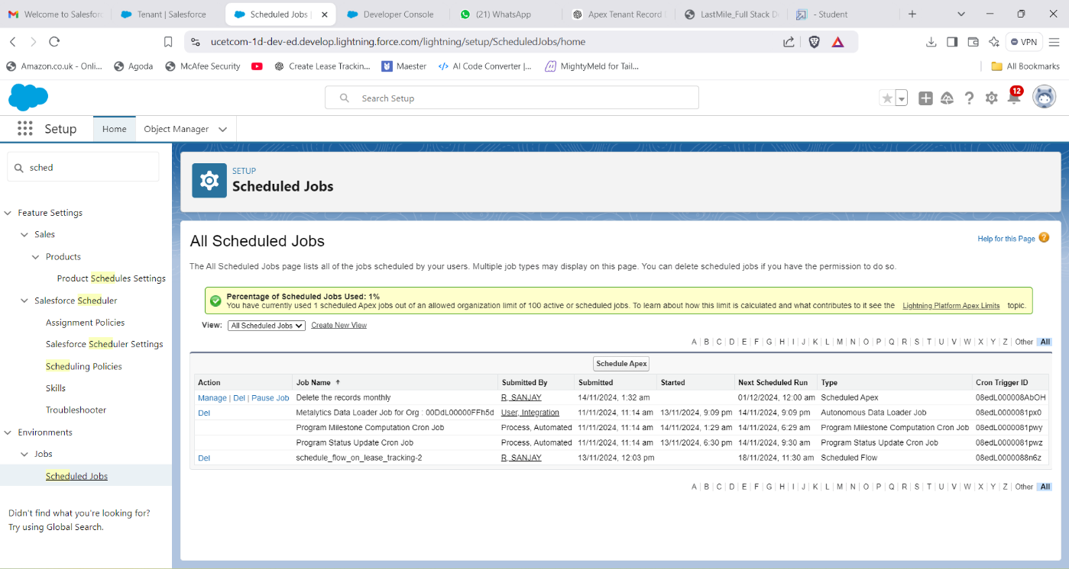**Figure** :25

1. **Create Reports and Dashboards**

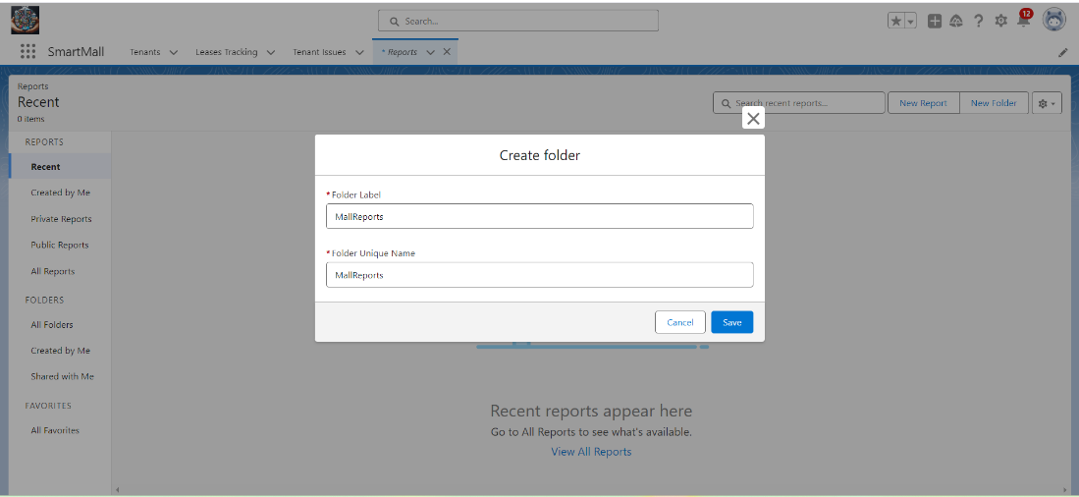**Figure:26**

* **Lease Management Records Report**: Displays lease details, including active and expired leases.

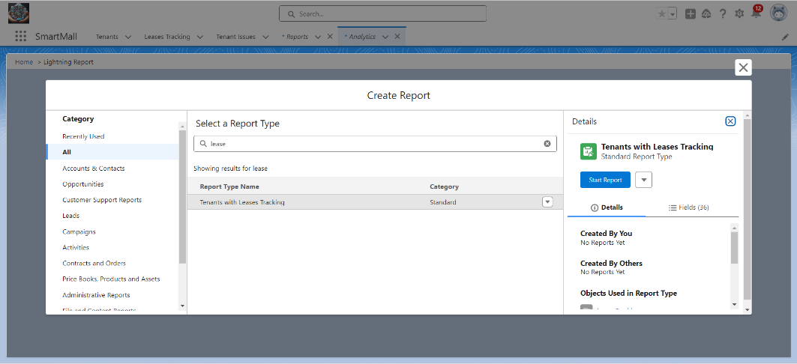**Figure**:27

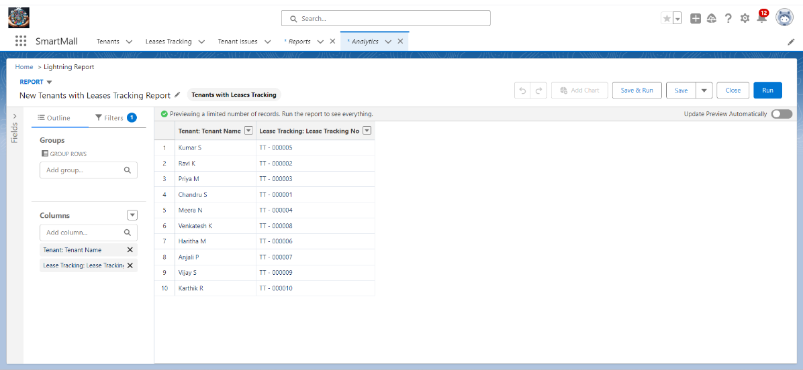**Figure:28**

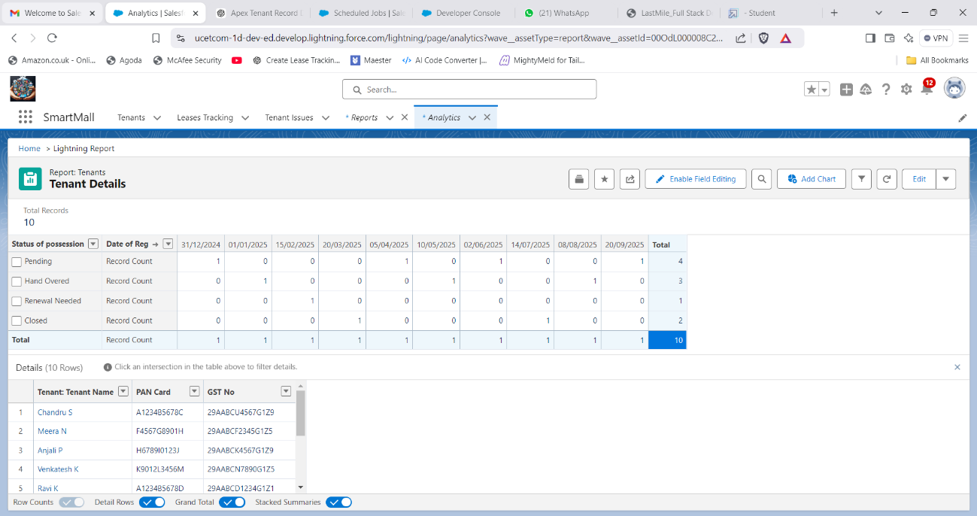**Figure:29**

**Figure: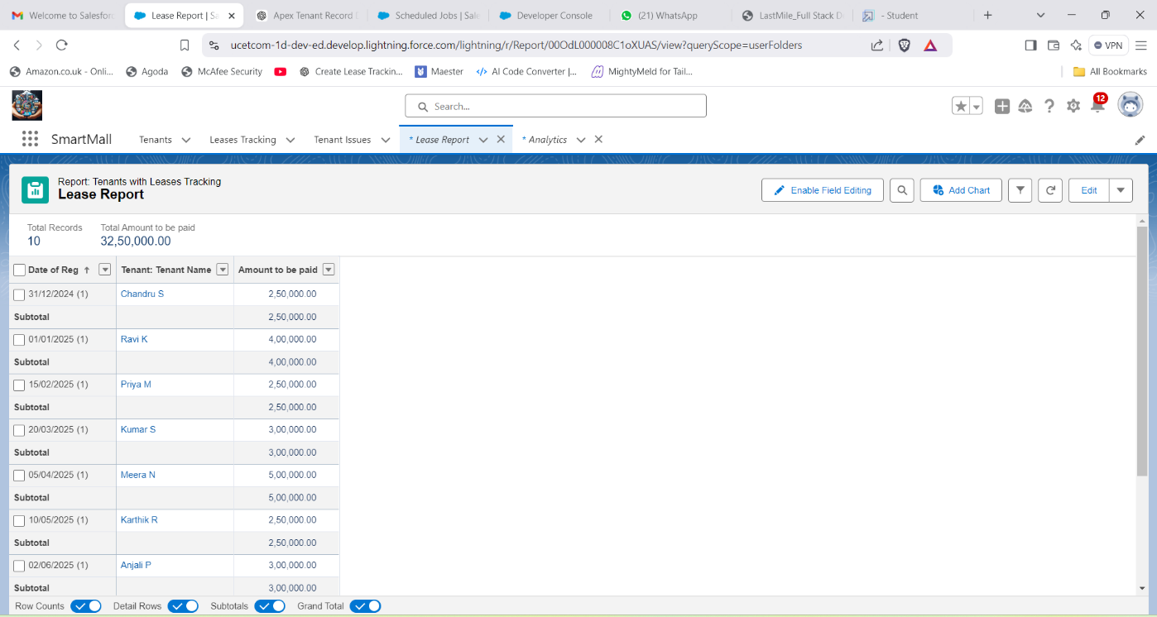30**

* **Tenant Issue Records Report**: Summarizes tenant complaints and their resolution statuses.
* **Custom Dashboards**: Visualize data for occupancy rates, tenant satisfaction, and lease renewal schedules.

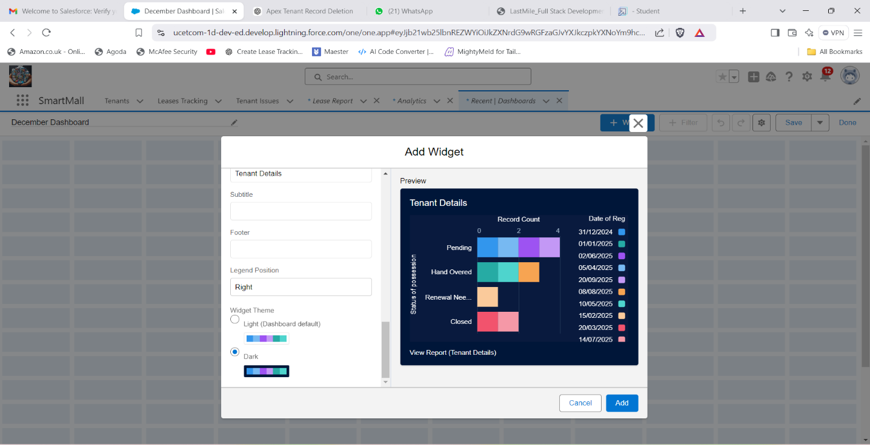**Figure:31**

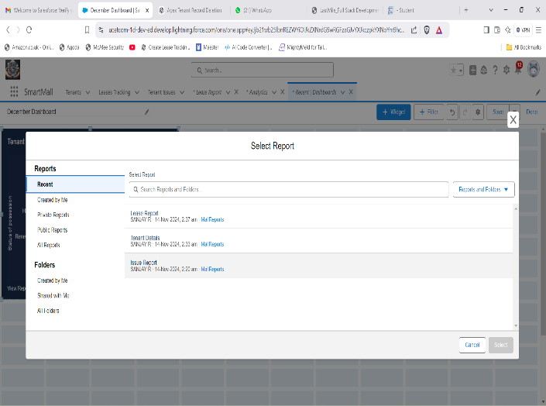**Figure:32**

**Figure:33**

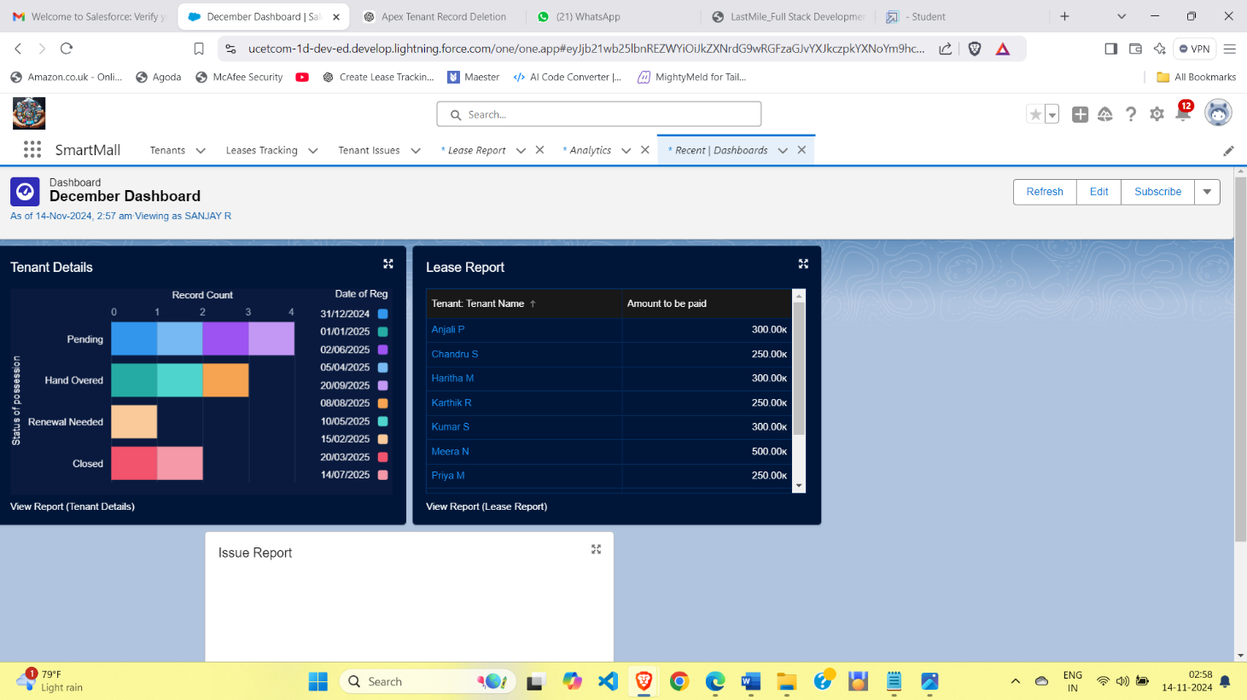

# Testing and Validation

The application underwent multiple rounds of testing to ensure functionality:

* **Unit Testing**:
  + Validated Apex triggers , Apex classes , workflows, and data relationships.
* **UI Testing**:
  + Ensured seamless navigation and data accuracy in Lightning pages.
* **Integration Testing**:
  + Confirmed smooth operation between custom objects and workflows.
* **Stress Testing**:
  + Evaluated system performance under high data loads to ensure smooth operation with hundreds of concurrent records.
* **End-User Testing**:
  + Conducted testing sessions with potential users (mall administrators) to gather feedback on usability and interface design.
* **Regression Testing**:
  + Verified that newly added functionalities, such as record-triggered flows, did not affect existing workflows.

By addressing edge cases and refining the application based on user feedback, the app ensures a seamless and efficient experience for its users

# Key Scenarios Addressed by Salesforce in the Implementation Project

* **Lease Renewal Notifications**: Alerts for leases nearing expiration.
* **Tenant Issue Resolution**: Centralized system for complaint tracking and resolution.
* **Financial Overview**: Dashboards showing rent collection progress and overdue accounts.
* **Rent Collection Alerts**: Automates reminders for overdue rent payments, ensuring timely revenue collection and reducing manual follow-ups.
* **Data Visualization**: Interactive dashboards provide insights into tenant retention rates, complaint resolution times, and lease expiration trends.
* **Tenant Onboarding**: Simplifies the process of onboarding new tenants with pre-configured templates for lease agreements and contact records.
* **Escalation Handling**: Implements workflows to escalate unresolved tenant complaints to higher management, ensuring accountability and swift resolution.

These scenarios ensure that all aspects of mall management are addressed, from tenant interactions to financial oversight.

# Conclusion

The Management App successfully integrates Salesforce’s powerful CRM capabilities with the unique requirements of mall management. By automating lease tracking, tenant communication, and reporting processes, the application ensures enhanced operational efficiency and improved tenant satisfaction. This project demonstrates the adaptability of Salesforce for building comprehensive industry-specific CRM solutions.